Mango Fruit Detection from Aerial Image
Leave this box blank.
Marawan Ashraf Fawzy Eldeib
Faculty of Engineering, Multimedia University, Persiaran Multimedia, Cyberjaya, 63100, Malaysia
E-mail: marawandeep13@gmail.com

Abstract— This study employs deep learning techniques, specifically Faster R-CNN models with VGG-16 and ResNet-50 architectures, to automate mango detection from aerial images. Utilizing a well-annotated dataset from previous research in Australia, this study focuses on adapting and refining these models for enhanced performance. Through rigorous training and evaluation, the models demonstrate high accuracy in distinguishing mangoes from the complex surroundings typical in orchards. The research confirms the effectiveness of employing advanced convolutional neural networks for agricultural applications, offering significant benefits for orchard management by improving the efficiency and accuracy of fruit detection.

Keywords— AI in Agriculture; Deep Learning; Faster R-CNN; Mango Detection; Aerial Imagery; Orchard Management.

Introduction
The integration of artificial intelligence (AI) into agriculture has revolutionized crop management and harvesting methods, introducing cutting-edge technologies for efficient farm supervision. Mangoes, which are in high demand and have significant nutritional value, have been a key focus of these improvements. Traditionally, identifying and quantifying mangoes in large orchards required extensive manual labor and was error-prone.

Recent advancements in computer vision and machine learning have facilitated the automation of such operations using aerial imagery, leading to significant improvements in accuracy and operational efficiency in orchard management. Unmanned aerial vehicles (UAVs) equipped with high-resolution cameras capture detailed images essential for analysis by deep learning models.

This study employs Faster R-CNN models, renowned for their exceptional object detection capabilities, particularly with VGG-16 and ResNet-50 architectures, to address unique challenges in orchard environments. These challenges include variations in illumination, obstacles posed by tree branches and foliage, and the diverse transformations of mangoes during ripening. The goal is to develop an automated mango detection system that balances speed and precision, enhancing efficiency and accuracy in orchard management.

Automation using deep learning reduces manual labor, increases detection accuracy, and identifies issues like diseases or pest infestations early. Improved detection facilitates better yield estimation, helping farmers optimize resource use and plan harvest and marketing strategies. The system is scalable for large orchards, making it suitable for commercial operations.

The global mango market, valued at $63.65 billion in 2023, is projected to grow to $67.95 billion in 2024, driven by increased income, exports, and demand for plant-based foods. This research, based on a highly annotated Australian dataset, aims to enhance mango orchard management through technological innovation.

The material and method
This section outlines the techniques used for dataset preparation, as well as the building and testing of deep learning models for automatic mango detection from aerial imagery.

DATASET DESCRIPTION AND PREPARATION
This research utilized a dataset of 1,964 high-resolution aerial images of mangoes, which were gathered and annotated as part of the ACFR Multi-fruit Dataset by the University of Sydney. The images are 500 x 500 pixels in size and are acquired in 16-bit/color RGB format. Each image has annotations in the form of rectangles that provide specific information on the position (x, y) and dimensions (dx, dy) of each mango. The images were captured under diverse environmental conditions.

The dataset was accessed from Google Drive and split into training and testing sets, with separate directories for images and annotation files. The images that were used were divided into two sets: a training set consisting of 500 images and a testing set consisting of 250 images. The annotation files were updated to reflect new bounding box dimensions and saved back to their respective CSV formats. The individual CSV files were then merged into single files for both training and testing, ensuring the dataset was properly structured for deep learning model training and evaluation.

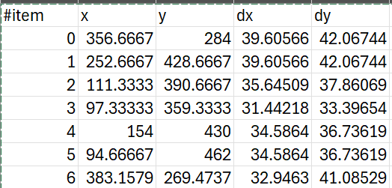
Fig 2 Example of rectangle annotation in a CSV file.

To enhance the robustness of the models and mitigate overfitting, data augmentation techniques such as rotations, translations, and horizontal flipping were applied to the training images. This strategy exposed the models to a variety of imaging conditions, simulating different angles and perspectives of mangoes in orchards.

To further enhance the dataset, additional imagery was gathered using drones, which captured videos of mango orchards. These videos were converted into still frames to augment the dataset.

OVERVIEW OF FASTER R-CNN MODEL ARCHITECTURE
For this study, the Faster R-CNN (Faster Regions with Convolutional Neural Networks) architecture was employed as the primary object detection model for mango detection from aerial images. The Faster R-CNN model consists of two main components: the Region Proposal Network (RPN) and the Fast R-CNN detector.

The RPN generates region proposals (bounding boxes) by sliding a small window over the input image and predicting object/non-object scores. The Fast R-CNN detector classifies objects within each proposed bounding box, refines the coordinates, and utilizes a convolutional neural network (CNN) for feature extraction. This is followed by a Region of Interest (RoI) pooling layer and fully connected layers for classification and bounding box regression.
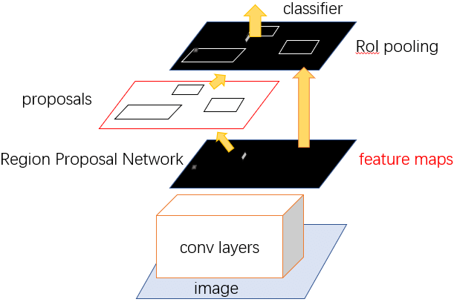
Fig 3 The Faster R-CNN architecture, illustrating the Region Proposal Network (RPN), RoI pooling, and the classifier components.

When employing the VGG-16 backbone, the Faster R-CNN architecture relies on a selective search algorithm, which generates sub-segmentations of the image based on color, texture, size, and shape, and iteratively combines similar regions to form objects.

OVERVIEW OF VGG-16 ARCHITECTURE
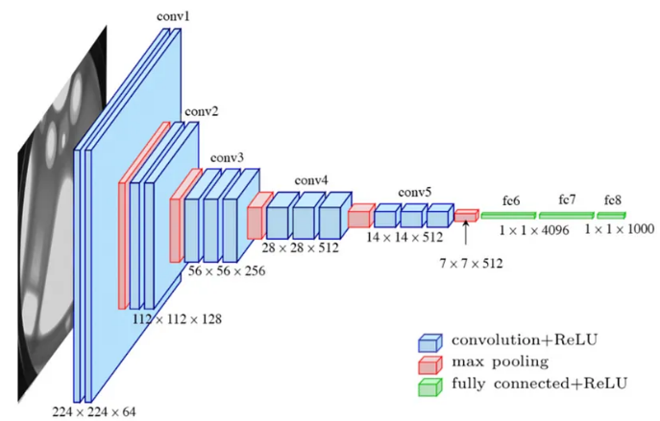
Fig 4 the architecture of the VGG-16 model.

The VGG-16 architecture, developed by the Visual Geometry Group, is admired for its straightforward design and deep structure, comprising a total of 16 convolutional layers. Specifically, it consists of thirteen convolutional layers, five max pooling layers to reduce spatial dimensions, and three dense layers, resulting in a total of 21 layers. The key factor in learning is the sixteen weight-bearing layers. The architecture is characterized by its uniformity, employing solely 3x3 convolutional layers stacked on top of each other with increasing depth. Max pooling is applied between these convolutional layers to decrease the spatial dimensions of the input volume. The architecture includes three fully connected layers and a SoftMax classifier, which, together, generate the model's final output. The basic architecture of VGG-16 enables clear comprehension and flexibility, though the extensive number of parameters can result in longer training durations.
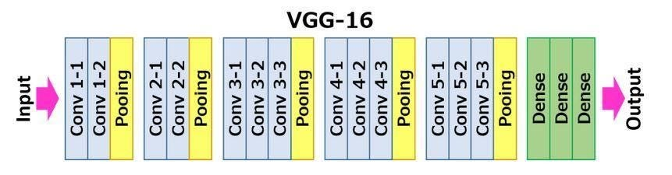
Fig 5 the architecture map of the VGG-16 model.

OVERVIEW OF ResNet-50 ARCHITECTURE
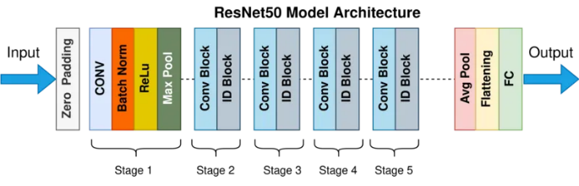
Fig 6 the architecture map of the ResNet50 model.
ResNet-50, a convolutional neural network (CNN), marked a milestone in deep learning when it was introduced in 2015 by Kaiming He et al. at Microsoft Research Asia. This architecture, part of the Residual Network (ResNet) family, utilizes residual learning and comprises 50 layers. Its innovative design overcomes the challenges of vanishing gradients, allowing for deeper architectures.

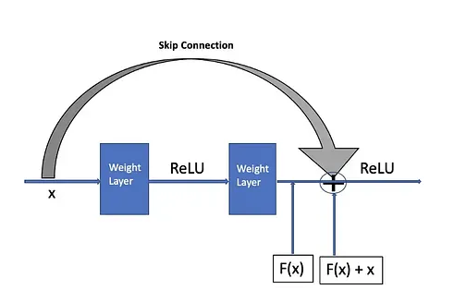
Fig 7 A skip connection in a residual block.

The network's architecture is built around residual blocks, which incorporate skip connections to bypass certain layers. This design enhances gradient flow and accelerates learning, allowing ResNet-50 to effectively learn identity functions. The components of ResNet-50 include:

Convolutional Layers: The network initiates with a convolutional layer, which utilizes filters to extract pertinent features from the input image, such as edges and textures. This is followed by a max-pooling layer, which reduces the spatial dimensions of the feature map while preserving the most salient aspects. This approach allows the network to focus on key features while enhancing computational efficiency. Subsequently, the network proceeds through several similar layers, each time extracting increasingly complex patterns.

Residual Blocks: Next, the network progresses through several residual blocks. Each block contains a series of convolutional layers, followed by batch normalization to stabilize the learning process, and ReLU activation to introduce non-linearity. The defining characteristic of residual blocks is the skip connection, which enables the input to bypass certain layers and connect directly to the output. This configuration facilitates the network's learning process by focusing on the residuals, thereby mitigating issues typically associated with deeper architectures.

Fully Connected Layers: The network concludes with fully connected layers, which consolidate the features learned in the previous stages into a single output. These layers facilitate the network’s final decision-making process regarding the contents of the input image. Typically, the fully connected layers are followed by a SoftMax classifier, which converts the network's output into a probability distribution, indicating the likelihood of the presence of specific objects, such as mangoes, in the image.

The architecture features skip connections, also known as identity connections, which retain information from earlier layers. While ResNet-50 offers robust performance, it can be computationally demanding to train and run.

The adopted architectures for mango detection were selected based on their established performance in object detection tasks. VGG-16 was chosen for its demonstrated ability to effectively capture texture and color details, while ResNet-50 was favoured for its deeper architecture, enabling the handling of complex patterns and variations in mango appearance. The decision to utilize pre-trained models on extensive datasets, such as ImageNet, was supported by research findings. This approach provides a robust knowledge base for the models to build upon. It should be noted that ResNet-50 may incur higher computational costs during training and inference due to its architectural complexity.

MODEL TRAINING AND EVALUATION
The VGG-16 and ResNet-50 models were trained using a structured approach to enhance their performance in identifying mangoes from aerial pictures.

Initialization and Configuration: The training used a stochastic gradient descent (SGD) optimizer with an initial learning rate of 0.001, decreasing by a factor of 10 every 10 epochs.

Batch Processing: The training process was divided into batches of 32 images. This approach helped to optimize memory usage and ensure more stable gradient updates throughout the training cycles.

Evaluation Metrics: Mean Average Precision (mAP) evaluates the overall accuracy of object detection or retrieval models by considering both precision and recall. It calculates the average precision across all classes and all recall values.

Mean Average Recall (mAR) measures a model's capability to capture relevant items, emphasizing recall over precision. It calculates the average recall across all classes and all precision values.

Training Loss is a measure to well how he model's predictions correspond to the actual labels during the training process. A decreasing training loss curve is typically a sign of effective learning, showing that the model is increasingly aligning its predictions with the observed data. Monitoring the training loss offers insights into convergence, optimization effectiveness, overfitting risks, and model comparison, aiding further optimization efforts.

Intersection over Union (IoU) determines the degree of similarity between a predicted region and the actual region by calculating the area of overlap between both. An IoU threshold is typically set to determine whether a prediction is considered a true positive or false positive.

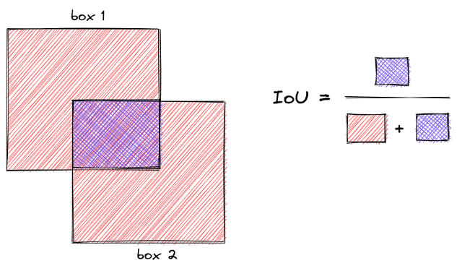
Fig 8 IoU - a metric that measures the overlap between two bounding boxes.

$$Precision= \frac{TP}{TP+FP}$$ | (1)
$$Recall= \frac{TP}{TP+FN}$$ | (2)
$$F1=\frac{2}{\frac{1}{Precision}+\frac{1}{Recall}}$$ | (3)

Where TP (True Positive): Mangoes correctly identified as mangoes; FP (False Positive): Other things (like leaves) wrongly identified as mangoes; and FN (False Negative): Mangoes missed by the identification system.

Precision measures the proportion of correctly identified mangoes out of all predicted positive cases. Recall measures the proportion of correctly identified mangoes out of all actual positive cases. The F1 Score is the harmonic mean of Precision and Recall, providing a balanced measure of the system’s performance.

These evaluation metrics provide a comprehensive assessment of the model's performance, considering different aspects such as precision, recall, and localization accuracy.

COMPUTATIONAL ENVIRONMENT
This study made use of Google Colab, Colab is a hosted Jupyter Notebook service that requires no setup to use, which provided the required GPU acceleration to handle the computational requirements of deep learning. The building and evaluation of models were facilitated by a collection of Python modules that have been specifically tuned for data science and machine learning tasks:

Torchvision: This package extends PyTorch and offers access to popular datasets, pre-trained models, and image manipulation capabilities for computer vision workloads.

NumPy: The essential Python library for scientific computing, handling multi-dimensional arrays and sophisticated mathematical operations rapidly.

Pandas: Commonly used for data manipulation and analysis, Pandas provides adaptable structures for structured data.

PIL (Python Imaging Library): Important for reading, manipulating, and saving various image formats, supporting image pre-processing procedures.

Matplotlib: A powerful plotting library for creating static, animated, and interactive visuals for data analysis and presentation.

These libraries formed the backbone of the project's computational workflow, ensuring a streamlined and effective model development process.
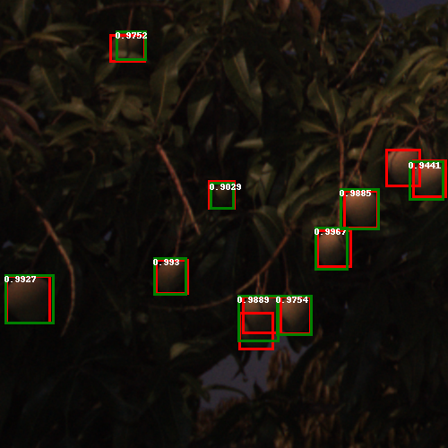  Fig 9 Example of mango detections using the VGG-16 model. Red bounding boxes represent ground truth annotations, and green bounding boxes represent model predictions. | 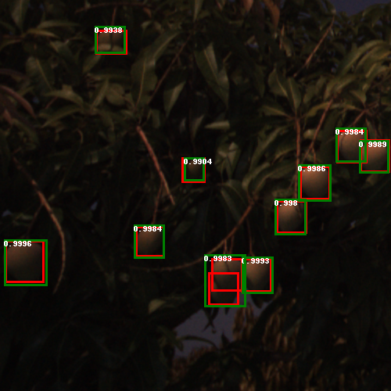  Fig 10 Example of mango detections using the ResNet-50 model. Red bounding boxes represent ground truth annotations, and green bounding boxes represent model predictions.
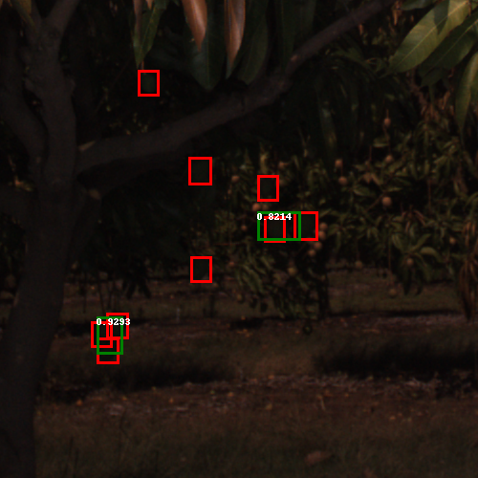Fig 11 Example of mango detections using the VGG-16 model, with correct detections (green) and missed detections (red) | 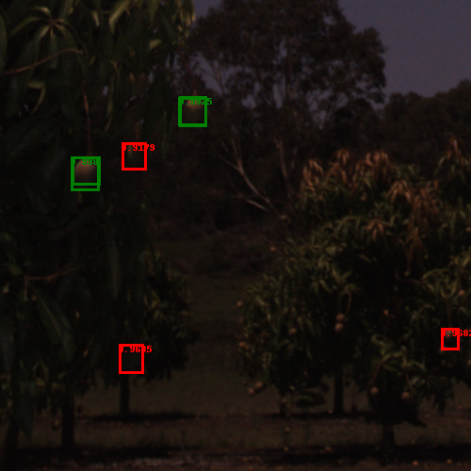Fig 12 Example of mango detections using the ResNet-50 model, with correct detections (green) and false positives (red)

Results and discussion
This section presents the results obtained from the deep learning models for the identification of mangoes in aerial images. In addition, this paper includes a discussion on the
implications of these models and potential areas for further research.

MODELS PERFORMANCE ANALYSIS

Model | mAP | mAR
VGG-16 (Model 1) | 0.572 | 0.646
ResNet-50 (Model 2) | 0.654 | 0.705
Table 1 Performance metrics for the VGG-16 and ResNet-50 models on the mango detection task

In this analysis, we compared the performance of two deep learning models, VGG-16 (Model 1) and ResNet-50 (Model 2), for mango detection. The results indicate that the ResNet-50 model outperformed the VGG-16 model in terms of both Average Precision and Average Recall, with a mean Average Precision (mAP)
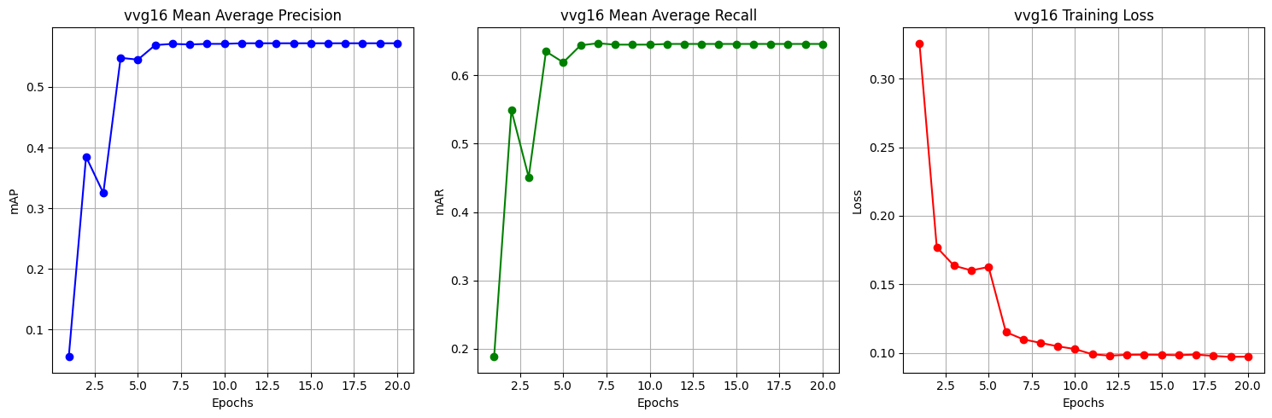
Fig 13 Performance curves for the VGG-16 model during training, showing mAP (blue), mAR (green), and Training Loss (red).
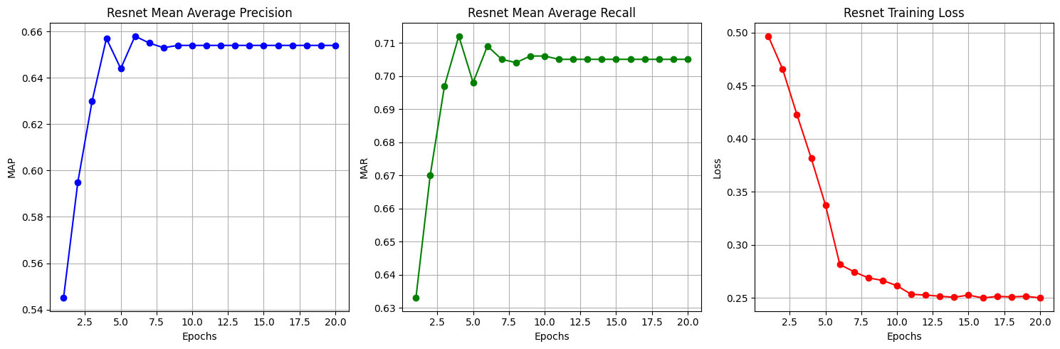
Fig 14 Performance curves for the ResNet-50 model during training, showing mAP (blue), mAR (green), and Training Loss (red)

of 0.654 and a mean Average Recall (mAR) of 0.705. The superior performance of ResNet-50 can be attributed to its deeper architecture and the use of residual connections, which facilitate more effective training of deeper neural networks. This results in improved feature extraction and better generalization.

Upon further examination, it is evident that deep learning models can achieve close to perfect precision in specific scenarios, provided they are properly fine-tuned and get adequate attention to detail during training. However, it should be noted that these results do not remain the same for all test cases, and the accuracy of detection may be influenced by the unpredictable nature of the surrounding environment, such as occlusion, varying illumination conditions, or the presence of other objects that can be mistaken for mangoes. It is extremely important to remember this concept.

VGG-16 PERFORMANCE CURVES DISCUSSION
The VGG-16 model demonstrates an initial rapid improvement in Mean Average Precision (mAP), peaking early before stabilizing at approximately 0.57. This stabilization might indicate an early saturation in learning, suggesting that the model reaches its performance limit given the current training regime and architecture. On the other hand, the Mean Average Recall (mAR) increases notably, stabilizing at 0.646, which indicates a reliable detection capability for the model.

The training loss decreases steadily, reflecting effective error reduction and model convergence. However, the plateau in loss suggests potential overfitting or the exhaustion of learning from the current data, pointing towards the need for adjustments in training methods or data augmentation to further enhance the model's performance.

Overall, VGG-16 shows strong initial learning capabilities but also reveals areas for improvement to optimize its application in detecting mangoes from aerial images.

ResNet-50 Model Performance Curves Discussion

ResNet-50 exhibits a steady and consistent increase in mAP, reaching a higher stabilization point at 0.654, demonstrating its superior capability in feature extraction and generalization, likely due to its residual connections that alleviate the vanishing gradient problem. The mAR also shows a robust increase and stabilizes at a higher value of 0.705, underscoring the model’s effectiveness in consistently identifying target objects across varied samples.

The decline in training loss is significant and maintains a low level, indicating efficient learning and prediction accuracy. This lower plateau in training loss signifies fewer prediction errors and suggests that the model is well-suited for deployment in complex detection environments.

The overall performance of ResNet-50, supported by deep learning architectural advantages, makes it a preferable model for tasks requiring high precision and reliability, such as agricultural monitoring and object detection from aerial imagery.

Conclusion
This study represents a substantial advancement in agricultural artificial intelligence, demonstrating the effectiveness of advanced deep learning techniques, specifically the VGG-16 and ResNet-50 models integrated with Faster R-CNN architectures, for detecting mangoes from aerial views. The evaluation of these models illustrates how their distinct structural designs impact their detection capabilities. Notably, the ResNet-50 model, with its deeper layers, significantly outperforms its counterpart by enabling more profound learning processes and addressing common computational challenges such as the vanishing gradient problem. This enhanced performance not only confirms the high precision and recall rates achieved but also underscores the potential of these technologies to boost productivity and efficiency in precision agriculture.

Both models exhibit rapid learning and a significant decrease in errors initially, yet they encounter limits to their performance with prolonged training on the same dataset, which may indicate a tendency towards over-specialization to the training data. This phenomenon could reduce their effectiveness in variable conditions, highlighting the essential need for continuous updates and refinements. These include tuning learning parameters, diversifying training datasets, and making architectural adjustments to enhance their robustness and adaptability in diverse agricultural environments.

Looking towards the future, one promising area for research involves the prediction of mango ripeness, differentiating between ripe, unripe, and overripe mangoes. Future models could incorporate additional features or leverage different architectures specifically designed for multi-class classification, such as using advanced convolutional neural networks or hybrid models. Creating a robust dataset with labelled images of mangoes at different stages of ripeness would be crucial, which could involve gathering high-quality images from various orchards and applying data augmentation techniques. Additionally, optimizing models for real-time inference, possibly through techniques like quantization or model pruning, and exploring deployment on edge devices or drones for on-the-fly predictions would enhance practical applications. The prediction of mango ripeness could also be integrated into broader orchard management systems, facilitating automated harvesting, resource management, and market planning based on ripeness distribution.

The work that is being done here shines a bright light on the future of precision agriculture, which is a field in which AI-driven solutions such as this one have the potential to greatly increase yield management and management efficiency. There is a significant possibility that these models might be expanded to include a wider range of agricultural applications, which would be a step towards more intelligent farming practices that are supported by modern technology.

Acknowledgment
I am deeply grateful to Mohd Haris Lye Abdullah for his expert guidance and mentorship which was crucial throughout the duration of this project.

References

